PART 3

28**. Define goods. What are the different types of goods?**

*In business law, the term "goods" refers to all movable property apart from actionable claims and money.*

This includes growing crops, grass, and other things attached to land or forming a part of the land, as well as stocks and shares. There are three main types of goods: existing goods, future goods, and contingent goods.

## Existing Goods

Existing goods are goods that physically exist and belong to the seller at the time of contract of sale. Existing can be further divided into two categories:

* **Specific Goods:** These are goods that are specifically agreed upon between the seller and buyer at the time of making the contract of the sale. For example, the seller may agree to sell the buyer a specific item bearing a specific number. These are sometimes known as "ascertained goods." This distinction becomes important because of the rules regarding the [transfer of property](https://www.upcounsel.com/transfer-of-rights-in-the-property) between parties.
* **Unascertained goods:** These are goods that are agreed upon at the point of making the contract of sale but are not specifically identified in the contract. For example, a seller may agree to sell a buyer one out of a number of items of the same type (e.g., bags of sugar) without defining which specific item the buyer will receive. As soon as the specific item is defined, for example when being prepared for delivery, this becomes specific, or ascertained goods.

## Future Goods

Future goods are goods that are not yet in existence or that do not yet belong to the seller when the contract of sale is made. This could be goods that are yet to be manufactured or that the seller has not yet acquired. For example, a farmer may agree to sell a buyer all of the milk produced by his/her cows in the coming year. This is called an "agreement to sell." Because the milk does not yet exist at the point of making the contract, it is an example of future goods.

## Contingent Goods

Although contingent goods are a type of future goods, they differ in that they are dependent on a specific contingency. For example, a seller may agree to sell a buyer some specific goods that are due to arrive on a particular ship. If, when the ship arrives, it does not contain those goods, the buyer will still have fulfilled his agreement, because the sale was contingent on the ship containing those specific goods.

29. **Briefly explain the conditions and warranties implied by law in a contract for the sale of goods.**

Section 14-17 of the Sale of Goods Act, 1930 deal with the implied conditions and warranties attached to the subject matter for the sale of a good which may or may not be mentioned in the contract.

**Implied Condition**

**Condition as to Title [Section 14(a)]**

Section 14(a) of the Sale of Goods Act 1930 explains the implied condition as to title as ‘in the case of a sale, he has a right to sell the goods and that, in the case of an agreement to sell, he will have a right to sell the goods at the time when the property is to pass’.

This means that the seller has the right to sell a good only if he is the true owner and holds the title of the goods or is an agent of the title holder. When a good is sold the implied condition for the good is its title, i.e. the ownership of the good. If the seller does not own the title of the said good himself and sells it to the buyer, it is a breach of condition. In such a situation the buyer can return the goods to the seller and claim his money back or refuse to accept the good before delivery or whenever he learns about the false title of the seller.

CASE LAW: ***Rowland v Divall, 192210*** – The plaintiff had purchased a car from the defendant and was compelled to return it to the true owner after having used it for a while. The plaintiff then sued the defendant for the purchase money, since the defendant didn’t receive the consideration as per the condition of the title of ownership.

**Sale by Description (Section 15)**

Section 15 of the Sale of Goods Act, 1930 explains that when a buyer intends to buy goods by description, the goods must correspond with the description given by the buyer at the time of formation of the contract, failure in which the buyer can refuse to accept the goods.

**Sale by Sample (Section 17)**

When the goods are to be supplied on the basis of a sample provided to the seller by the buyer while the formation of a contract the following conditions are implied:

* Bulk supplied should correspond with the sample in quality
* Buyer shall have a reasonable opportunity to compare the goods with the sample
* The good shall be free from any apparent defect on reasonable examination by the buyer.

**Sale by sample as well as Description (Section 15)**

When the sale of goods is by a sample as well as a description the bulk of the goods should correspond with both, i.e. description and sample provided to the seller in the contract and not only sample or description.

**Condition as to Quality or Fitness (Section 16)**

The doctrine of Caveat Emptor is applicable in the case of sale/purchase of goods, which means ‘Buyer Beware’. The maxim means that the buyer must take care of the quality and fitness of the goods he intends to buy and cannot blame the seller for his wrong choice. However, section 16 of the Sale of Goods Act 1930 provides a few conditions which are considered as an implied condition in terms of quality and fitness of the good:

* When the buyer specifies the purpose for the purchase of the good to the seller, he relied on the sound judgment and expertise of the seller for the purchase there is an implied condition that the goods shall comply with the description of the purpose of purchase.
* When the goods are bought on a description from a person who sells goods of that description (even if he doesn’t manufacture the good), there is an implied condition that the goods shall correspond with the description. However, in case of an easily observable defect that is missed by the buyer while examining the good is not considered as an implied condition.

**Implied Warranty**

**Enjoy Possession of the Goods [Section 14(b)]**

Section 14(b) of the Act mentions ‘an implied warranty that the buyer shall have and enjoy quiet possession of the goods’ which means a buyer is entitled to the quiet possession of the goods purchased as an implied warranty which means the buyer after receiving the title of ownership from the true owner should not be disturbed either by the seller or any other person claiming superior title of the goods. In such a case, the buyer is entitled to claim compensation and damages from the seller as a breach of implied warranty.

**Goods are free from any charge or encumbrance in favour of any third party [Section 14(c)]**

Any charge or encumbrance pending in favour of the third party which was not declared to the buyer while entering into a contract shall be considered as a breach of warranty, and the buyer is be entitled to compensation and claim damages from the seller for the same.

30. Distinguish between conditions and warranties.

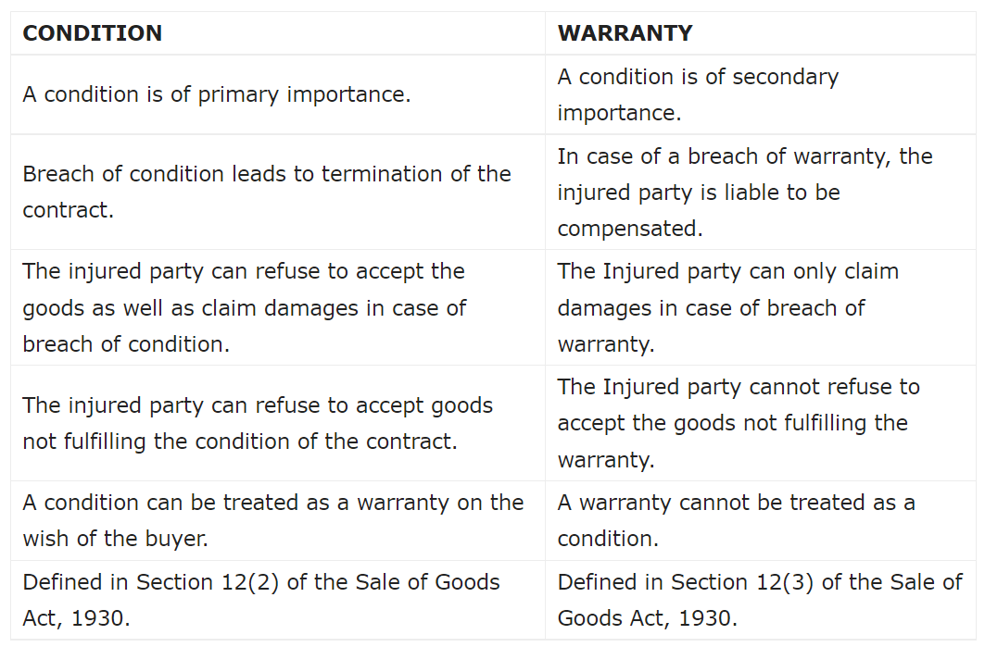

31. **State the rules as to passing of property from the seller to the buyer**.

Rules Regarding Transfer of Property Under this topic, we will study that in case of different types of goods, when the transfer of property/ ownership in goods takes place from seller to buyer. For this purpose we have two heads:

1. Specific goods and ascertained goods (for both of them rule is same)

2. Unascertained goods and future goods (for both of them rule is same)

**1.Specific goods and ascertained goods (for both of them rule is same)**

**a) Deliverable State** The specific/ ascertained goods must be in deliverable state which means the state in which buyer can’t refuse the delivery of the goods and bound to take the delivery of the goods.

Example: Polished furniture is ready for purchase at the showroom. Here, furniture is in deliverable state. Rules: The ownership/property in goods is said to be transferred immediately from the seller to the buyer at the time of contract.

**b) Non- Deliverable State** The specific/ ascertained goods are not in deliverable state which means some work is still required to be finished before the delivery can be given to the buyer.

Example: Polishing of furniture is required before delivery of the goods. So, here goods will be in deliverable state once the polishing is completed. Rule: The ownership/property in goods is said to be transferred from the seller to the buyer once the goods are in deliverable state and the notice for the same is given by seller to the buyer. Till the time it’s in non-deliverable state, then the ownership lies with the seller only.

**c) Price / weight/ measurement of the goods yet to be determined** Pricing/ weight/ measurement of the specific/ ascertained goods is not known at the time of contract so, till the time it is not known the ownership remains with the seller.

Rules: The ownership/property in goods is said to be transferred from the seller to the buyer at the time when price/ weight/ measurement of the goods is determined and the notice for the same is given by seller to the buyer.

**d) Where goods are delivered on Approval Basis Rules**: The property in goods passes from seller to the buyer: à When buyer gives his approval or acceptance to the seller or does any other act of giving approval to the transaction like, consumes the goods, resells the goods to third party etc. à When buyer does not gives his approval or acceptance to the seller but retains the goods without giving the notice of rejection beyond the time fixed for the return and if no time is fixed, after the expiry/ lapse of the reasonable time.

**2.Unascertained goods and future goods (for both of them rule is same)**

**a) Ascertainment of Goods** Firstly, unascertained goods need to be ascertained, then only the ownership transfers from seller to the buyer. Till the time goods are unascertained the ownership remains with the seller.

Example: A agrees to sell B, 10 litres of Mustard Oil from the 100 litres of oil available with A. B agrees and paid the price for the same to A. So, here till the time 10 litres oil is separated from the 100 litres of oils available, it will be called unascertained goods and property in goods does not pass to B. It remains with A (seller).

Rule: Firstly, goods need to be ascertained, then only the ownership transfers from seller to the buyer. Till the time goods are unascertained the ownership remains with the seller.

**b) Unconditional Appropriation of Goods** Seller and buyer mutually selects the goods for the buyer without any condition attached to it or gives consent mutually for selecting the goods.

Essentials of Valid Appropriation:

* 1. Selection of goods
  2. Selection of goods may be based on sample or description provided
  3. Goods must be in deliverable state iv) Consent by buyer and seller- express or implied

32. **What do you meant by sale by Non-owners? Give exceptions.**

Nemo Dat Quod Non-Habet (Sale by Non Owners)

Basically, Nemo Dat Quod Non-Habet means that seller should have the ownership of goods in order to sell them to the buyer. But, there are few exceptions to it (which means even non-owners can sell even if they don’t have the ownership of goods).

**Exceptions to Nemo Dat Quod Non-Habet**:

1. **Sale by estoppel** - A statement or conduct leads the buyer to believe that the person selling the goods has the authority to sell them. And the actual owner don’t show any objection regarding the sale transaction. This will be considered sale by estoppel if below mentioned conditions are fulfilled:

a. The actual owner don’t show any objection regarding the sale transaction

b. Buyer acted in good faith (buyer don’t have any doubt)

2. **Sale by mercantile agent** - Mercantile agent is a person who is appointed by principal to do some acts on his behalf. So, mercantile agent can sell the goods on behalf of principal even if he is not the actual owner of the goods. But below mentioned conditions should be fulfilled by mercantile agent:

a. Possession of goods with consent of principal

b. Acting in ordinary course of business (following lawful ways to sell the goods)

c. Buyer acted in good faith (buyer don’t have any doubt)

d. No notice of no authority to sell given by principal

3. **Sale by joint owner –**

Example: There are two persons A & B who jointly owns a Gold Bar. They will be called joint owners. Here, both of them are owners. Ownership is divided between them. If one owner want to sell gold bar then below mentioned conditions needs to be fulfilled:

1. Sole possession of goods with other joint owners consent
2. Buyer acted in good faith (buyer don’t have any doubt)
3. No notice of no authority to sell

**4. Sale by person in possession of goods under voidable contract** - We have already done voidable contract. Now only explaining this point here. If the cheated party do not take any action then the other party who has obtained the goods by coercion/ undue influence etc. can sell the goods provided below mentioned conditions are fulfilled:

* 1. Possession of goods under voidable contract (through coercion, undue influence etc) by other party
  2. Goods sold before contract is cancelled by cheated party
  3. Buyer acted in good faith (buyer don’t have any doubt)

**5. Sale by seller in possession of goods after sale** –

Example: A has sold goods to B however A has not made delivery of goods to B that means A still possesses the goods and sold the same goods to C. Here, this is only possible that A can sell goods to C if below mentioned conditions are fulfilled:

* 1. Continues to have the possession of goods (that means A still has the possession of goods which is being sold to B. And now he is selling it to C)
  2. Buyer has no knowledge of the previous sale (that means C does not have the knowledge of sale between A and B)
  3. Buyer acted in good faith (buyer- C in this case, don’t have any doubt)

1. **Sale by buyer before transfer of ownership** –

Example: A has not sold the goods to B but only delivered the goods to B that means only the possession of goods is transferred. So, here this does not make “B” a buyer and “A” a seller. There is only bailer (A) and bailee (B) relation created and A remains the actual owner. But still B sold the goods to C, and this transaction is valid if the below mentioned conditions are followed and hence, C will become the actual owner of the goods:

* 1. Buyer (B) possesses goods with the consent of seller (A)
  2. New buyer ( C) has no knowledge of the transaction happened between A and B
  3. New buyer acted in good faith (buyer don’t have any doubt)

1. **Sale by unpaid seller** –

An unpaid seller can take the goods back and resell those goods even if, now unpaid seller is not the actual owner.

Example: A sold and delivered goods to B. But B didn’t paid the amount to A for goods. So, here A can take back the goods from B and resell them to another person even if now he is not the actual owner.

**Exceptions under other acts/ provisions** –

* 1. Sale of goods/ property by official receiver or liquidator of an insolvent person In this case, official receiver or liquidator of an insolvent person is not the actual owner but still can make the sale of goods/ property of insolvent person.
  2. Finder of goods If finder of goods is not able to find the actual owner of the goods or the expenses to be borne by finder of the goods is very high to keep the goods safe, then finder of the goods has the right either to dispose off those goods or sell them to another person even if finder of the goods is not the actual owner.
  3. Sale by pawnee under pledge

Example: A (Pawnor) has taken loan from B (Pawnee) for Rs. 10,000 by pledging the GOLD as security. If A does not repay the amount to B then B has the right to recover the amount of loan by selling gold to another person even if B is not the actual owner of the goods.

33. **Describe the rules of Delivery of goods under the contract of sale of goods.**

**Rules for Delivery of Goods**

Following are the [rules for delivery of goods](https://www.geektonight.com/rules-for-delivery-goods/#rules-for-delivery-of-goods):

1. [**Delivery and Payment are Concurrent Conditions**](https://www.geektonight.com/rules-for-delivery-goods/#delivery-and-payment-are-concurrent-conditions)

Unless otherwise agreed, delivery of goods and payment of price are concurrent conditions. In other words, the seller shall be ready and willing to give the possession of the goods to the buyer in exchange for the price and the buyer shall be ready and willing to pay the price in exchange for possession of the goods. For example, in a cash sale both the parties perform their respective obligations simultaneously.

1. [**Modes of Delivery**](https://www.geektonight.com/rules-for-delivery-goods/#modes-of-delivery)

Irrespective of the mode of delivery whether actual, symbolic or constructive, it must have the effect of putting the goods in the possession of the buyer or his authorized agent.

1. [**Effect of Part Delivery**](https://www.geektonight.com/rules-for-delivery-goods/#effect-of-part-delivery)

Section 34 of Sale of Goods Act lays down two rules in this regard, which are as follows:

1. Where the part delivery is made in progress (in continuation) of the whole delivery, then it is treated as a delivery of whole and the ownership of the whole quantity is supposed to pass to the buyer.
2. Where the part delivery is made with the intention of separating it from the whole lot, then such part delivery does not operate as delivery of the remainder part also. It means that delivery of a severed (separated) part is not treated as a delivery of the whole and therefore the ownership of the whole quantity is not transferred to the buyer such part of goods is delivered to him.
3. [**Buyer to Apply for Delivery**](https://www.geektonight.com/rules-for-delivery-goods/#buyer-to-apply-for-delivery)

Section 35 of Sale of Goods Act provides that if there is no express agreement between the parties to its contrary, the seller of goods is not bound to deliver them until the buyer applies for delivery. Thus, it is a statutory obligation on the buyer to call upon the seller to perform delivery.

1. [**Place of Delivery**](https://www.geektonight.com/rules-for-delivery-goods/#place-of-delivery)

According to Section 36(1) of Sale of Goods Act, whether the buyer is to take possession of the goods or the seller is to send them, is a question that depends upon the terms of the contract and therefore it will differ from case to case.

1. [**Time of Delivery**](https://www.geektonight.com/rules-for-delivery-goods/#time-of-delivery)

Where the place of delivery is agreed upon, the goods are delivered at that place during business hours on a working day. Section 36 (2) of the Act provides that where the seller is bound to send the goods to the buyer under the terms of the contract but no time for sending them is fixed, the seller is bound to send them within a reasonable time.

1. [**Acknowledgement by a Third Person**](https://www.geektonight.com/rules-for-delivery-goods/#acknowledgement-by-a-third-person)

Section 36(3) of the Act lays down that where the goods at the time of the sale are in the possession of a third person, there is no delivery by seller to buyer unless and until such third person acknowledges to the buyer that he holds the goods on his behalf.

1. [**Expenses of Delivery**](https://www.geektonight.com/rules-for-delivery-goods/#expenses-of-delivery)

Section 36(5) of the Act provides that unless otherwise agreed, the expenses of putting the goods into a deliverable state and also the incidental expenses in this connection both shall be borne by the seller.

1. [**Delivery of Wrong Quantity and Quality**](https://www.geektonight.com/rules-for-delivery-goods/#delivery-of-wrong-quantity-and-quality)

Section 37(4) lays down that if there is no usage of trade, or no special agreement or no course of dealing between the parties, then the following rules shall apply when delivery of wrong quantity and quality is made:

* **When quantity is short**
* **When quantity is in excess:**
* **When the quality is mixed:**

1. [**Instalment Deliveries**](https://www.geektonight.com/rules-for-delivery-goods/#instalment-deliveries)

In the absence of an agreement to the contrary, the buyer is not bound to accept delivery by instalments. [Section 38(1)] Sometimes, there may be a contract where goods sold are to be delivered by separate instalments each of which is to be separately paid for.

1. [**Delivery to Carrier or Wharfinger**](https://www.geektonight.com/rules-for-delivery-goods/#delivery-to-carrier-or-wharfinger)

In this connection there are the following rules:

1. Where the seller is authorised or required to send the goods to the buyer, the delivery of the goods to a carrier for the purpose of transmission to the buyer of the delivery of the goods to a wharfinger for safe custody, is prima facie deemed to be a delivery of the goods to the buyer. Section 39(1)
2. It is the duty of the seller to make with the carrier or the wharfinger such contract as would sufficiently protect the buyer’s interest in the goods. If he fails in his duty and the goods are lost or damaged, then the buyer may hold the seller liable for damages or he may refuse to treat the delivery to the carrier or the wharfinger as delivery to himself. Section 39(2)
3. Unless otherwise agreed, in cases where goods are sent to the buyer by a route involving sea transit and it is usual to get them insured, then it is the duty of the seller to give such notice to the buyer so as to enable him to insure the goods. If the seller fails to do so, the goods shall be deemed to be at his risk during the sea transit.
4. [**Buyer’s Risk for Deterioration of Goods in Transit**](https://www.geektonight.com/rules-for-delivery-goods/#buyers-risk-for-deterioration-of-goods-in-transit)

According to Section 40 of the Sale of Goods Act, where goods are delivered at a distant place, the liability of such deterioration in the goods as is necessarily incidental to the course of transit, will fall on the buyer even though the seller agrees to deliver them at his own risk.

1. [**Buyer’s Right of Examining the Goods**](https://www.geektonight.com/rules-for-delivery-goods/#buyers-right-of-examining-the-goods)

Section 41 of the Act lays down that where those goods are delivered to the buyer which he has not previously examined, he is entitled to examine them for his satisfaction. He is not deemed to have accepted them unless and until he has had a reasonable. opportunity for such examination. And unless otherwise agreed, the seller is bound to afford the said opportunity at the time of delivery if the buyer requests for the same.

1. [**Acceptance of Delivery by Buyer**](https://www.geektonight.com/rules-for-delivery-goods/#acceptance-of-delivery-by-buyer)

According to Section 42 of Sale of Goods Act, the buyer is deemed to have accepted the goods:

1. When he intimates to the seller that he has accepted them.
2. When the goods have been delivered to him and he does any act in relation to them which is inconsistent with the ownership of the seller, for example, he pledges them or resells them.
3. When after the lapse of a reasonable time, he retains the goods-without intimating to the seller that he has rejected them.
4. [**Buyer not Bound to Return Rejected Goods**](https://www.geektonight.com/rules-for-delivery-goods/#buyer-not-bound-to-return-rejected-goods)

Section 43 of the Sale of Goods Act lays down that unless otherwise agreed, where the buyer refuses to take delivery of the goods and if he has a right to do so, he is not bound to return them to the seller, but it is sufficient if he intimates to the seller that he refuses to accept them.

1. [**Liability of Buyer for Neglecting or Refusing Delivery of Goods**](https://www.geektonight.com/rules-for-delivery-goods/#liability-of-buyer-for-neglecting-or-refusing-delivery-of-goods)

According to Section 44 of the Act, when the seller is ready and willing to deliver the goods and requests the buyer to take delivery and the buyer does not take delivery within a reasonable time after such request, the buyer is liable to the seller for loss occurred by his neglect or refusal to take delivery; and also for a reasonable charge for the care and custody of the goods.

34. **When is a seller of goods deemed to be an unpaid seller? What are his rights?**

**Features of an unpaid seller**

1. Seller must sell the goods on cash basis and must be unpaid (in cash transactions payment becomes due instantly)

2. Seller must be unpaid either wholly or party

3. The decided period has expired and the price has not been paid to seller

4. Seller must not refuse to accept the payment

5. Where the price paid through negotiable instrument (bill of exchange/ promissory note/ cheque) and the same has been dishonoured.

# **Right of an unpaid seller**

# **Rights against buyer**

## **1- Suit for the price**

When any goods are passed on to the buyer and the buyer has wrongfully neglected or refused to pay as per the terms and conditions of the contract, the seller may sue him as per the [Section 55(1)](https://indiankanoon.org/doc/1971471/)because once the property has been passed the buyer is bound to pay the price. But in the case due date of payment has been passed and goods had not been delivered yet, the seller can sue the buyer for the wrongful neglect or refusal on his part according to [clause 2 of Section 55](https://indiankanoon.org/doc/1971471/).

## **2- Suit for damages**

In case there is a wrongful refusal on the part of buyer for acceptance of goods and payment of money, the seller can sue him for damages of non-acceptance as per [Section 56](https://indiankanoon.org/doc/896079/). For calculating the quantum of damages [Section 73 and 74 of the Indian Contract Act](https://singhania.in/liquidated-damages-section-73-section-74/)applies. In case the goods have a ready market, the seller has to resell the goods and buyer have to pay the losses if incurred. If the seller does not resell the goods the difference between contract and market price at the day of breach is taken as a measure for damages. If the difference between them is nil seller gets nominal value.

## **3- Suit for interest**

As stated under [Section 61](https://indiankanoon.org/doc/741531/), where there is a specific agreement between buyer and seller with regards to interest on the price of goods from the date on which payment becomes due, the seller may recover interest from a buyer. But if there were no such agreement the seller may charge interest from the day he notifies the buyer. If there is no contract to the contrary, the court of law may award interest to the seller at such rate as it thinks fit on the amount of the price from the date on which amount is payable.

# **Rights against goods**

## **a- Lien**

Lien is a right which seller of goods can exercise when a buyer has not paid the price of goods, under this right seller can retain the possession of goods as an agent or bailee for the buyer. The seller can retain his possession as per [Section 47](https://indiankanoon.org/doc/1218839/)under the following circumstances:

1- In case the buyer is insolvent.

2- When the term of goods sold on credit is expired.

3-  Goods sold without any stipulation as to credit.

When the goods are sold on credit the right to lien is suspended during the term of credit and lien exist only for the price of goods, not any additional charges.

## **b- Stoppage**

When the goods have been transferred to carrier or bailee for the purpose of transmission to the buyer, who has become insolvent, the seller has the right to stop the goods in transit in order to protect himself against the loss that may arise due to insolvency. As per Section 50, there are four essential requirements for stopping the goods in transit:

1. Unpaid seller.
2. Buyer insolvent.
3. Property should have passed to the buyer.
4. Property should be in course of transit.

The course of transit depends upon the capacity of middleman to hold the goods. Middleman should be an intervening person between the seller who has parted with the goods and the buyer who has not yet received the goods as held in the case of *[Schotsmans v Lancashire & Yorkshire Rly co.](https://discovery.nationalarchives.gov.uk/details/r/C7883108" \t "_blank)*

## **c- Resale**

Exercising the right of lien or stoppage does not rescind the agreement but reselling of goods does and without this right, the other two rights of lien and stoppage would not be of much usage because he can only retain goods under these right till the buyer pays back the money.

The unpaid seller can exercise his right under following conditions and circumstances-

1- Seller before reselling the goods needs to send a notice to the buyer except in the case of perishable goods, giving him last chance to pay the price and take back the goods within a reasonable time. If the buyer does not pay the money back seller has the right to resell the goods. If the seller fails to give notice of his intention to resell, he cannot claim damages from the buyer and he has to give any profit.

2- If there is any loss in the resale of goods he can claim the loss from the buyer, on the contrary, if there is profit buyer cannot claim it.

3- Seller gives rightful ownership to buyer after the resale it does not matter notice of resale is given or not to defaulted buyer.

4- Sometimes the seller reserves exclusive right to resale the goods if the buyer makes a default in payment, in such cases the buyer cannot ask for profit on resale if no notice is served and seller has the exclusive right to resale.

**35. What is Auction Sale? Explain the procedure.**

Auction Sale - An auction sale is a public sale. The goods are sold to all members of the public at large who are assembled in one place for the auction. Such interested buyers are the bidders. The price they are offering for the goods is the bid. And the goods will be sold to the bidder with the highest bid.

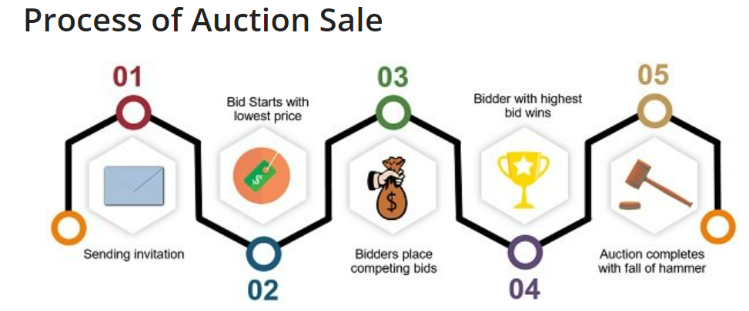

1. The process of auction sale starts with**sending an invitation** to the parties for auction. For this purpose, circulation of an advertisement and catalogue of the goods under auction along with the terms of sale takes place.
2. In this process, the bidders act as competitors and thus **they place competing bids**. In essence, each subsequent bid is higher in price than the last one.
3. When the auctioning begins, the**auctioneer starts with the lowest deal price**. He does so to gather the attention of most of the bidders. The interested buyers offer bids one after another and seek to outbid each other. And so, with each next bid, the price keeps on increasing until it reaches a point where no other bidder offers a higher price than the last one.
4. Therefore, the **item goes to the highest bidder** present at the time.
5. An auction sale is complete when the auctioneer signals it by **the Fall of a Hammer** or any other customary way. And with the Fall of Hammer, the property in goods passes to the highest bidder. And so, until the fall of the hammer, the bidder can revoke his offer, if he wants to.
6. As soon as the vendor accepts the highest bid offered, the auction comes to end. Thereafter, the **buyer has to pay the agreed price** and take possession.
7. After that, the auctioneer can ask for **payment of the sale money via cash**. The buyer cannot compel the auctioneer to accept payment of money by way of a bill of exchange or cheque.

36. **What are the objectives of Consumer Protection Act.**

# **Objective of the Consumer Protection Act, 2019**

The main objective of the Act is to protect the interests of the consumers and to establish a stable and strong mechanism for the settlement of consumer disputes. The Act aims to:

1. Protect against the marketing of products that are hazardous to life and property.
2. Inform about the quality, potency, quantity, standard, purity, and price of goods to safeguard the consumers against unfair trade practices.
3. Establish Consumer Protection Councils for protecting the rights and interests of the consumers.
4. Assure, wherever possible, access to an authority of goods at competitive prices.
5. Seek redressal against unfair trade practices or unscrupulous exploitation of consumers.
6. Protect the consumers by appointing authorities for timely and sufficient administration and settlement of consumers’ disputes.
7. Lay down the penalties for offences committed under the Act.
8. Hear and ensure that consumers’ welfare will receive due consideration at appropriate forums in case any problem or dispute arises.
9. Provide consumer education, so that the consumers are able to be aware of their rights.
10. Provide speedy and effective disposal of consumer complaints through alternate dispute resolution mechanisms.

37. What are the Consumer Protection Councils organised? Explain

38. **Describe the various consumer protection councils. Their formation and objectives.**

Following are the consumer protection councils  -

(1) **Consumer Education And Research Center (Gujarat)**- CERC is a recognised consumer organisation by the Government of India and Government of Gujarat. It is dedicated to the cause of consumer protection, environment protection, investor protection and public health and safety issue.

(2)**Bureau Of Indian Standards**- BIS is the National Standard Body of India established under the BIS Act 2016 for the harmonious development of the activities of standardization. The Product Certification Schemes of BIS aims at providing Third Party assurance of quality, safety and reliability of products to the customer.

(3)**Federation Of Consumer Organisation In Tamil Nadu**-Cuddalore District Consumer Protection Organisation is a not-for-profit organisation based in Tamil Nadu which aims to protect the interests of consumers through campaigning, to educate consumers on their rights to legal redressal and to hold workshops and training for consumer activists.

(4) **Mumbai Grahak Panchayat**-Mumbai Grahak Panchayat (MGP) is perhaps the largest voluntary consumer organisation in India with a membership of 24,500 families. It has been engaged in activities of consumer protection and education for the last 33 years. Its unique collective group buying system provides a best practice model for sustainable consumption

(5) **Consumer Voice (New Delhi)**-VOICE is an acronym for Voluntary Organisation in Interest of Consumer Education which has pioneered the protection of consumers in India. Based in New Delhi, the organisation has championed consumer education in the country since 1983.

(6)**Legal Aid Society (Kolkata)**- Legal Aid Services, West Bengal (LASWEB), one of the pioneering legal aid offering civil society organizations in India, empowers the poor and the disadvantaged with varied legal entitlements. Functioning since 1980 as an organic collective of retired judges, practising lawyers and social activists.

(7) **Akhil Bhartiya Grahak Panchayat**-The Pioneer of Indian Consumer Movement, Grahakteerth Hon. Shri Bindumadhav Joshi is the founder of this organization. Inspired by him, Dr. Vijay Lad registered this organization. Grahaktirth Hon. Bindumadhav Joshi is the founder president of Akhil Bhartiya Grahak Panchyat, Freedom Fighter and Ex Minister.

(8) **The Consumers Eye India.**-The Consumer Guidance Society of India (CGSI) is a Non-Profit consumer organization established in [India](https://en.wikipedia.org/wiki/India) in 1966 to protect and educate the Indian consumer about sub-standard products and services, adulterated foods, short weights and measures, spurious and hazardous drugs, exorbitant prices, endemic shortages leading to black marketing and profiteering, unfulfilled manufacture guarantees, and a host of other problems

(9)**United India Consumer's Association**- Consumers Association of India (CAI) is a membership-based organisation with 8,000 registered members all over India. Its main objectives are: spreading consumer awareness; empowering consumers and teaching them their responsibilities and rights as consumers. CAI regularly conducts seminars, workshops and training programmes and publishes various consumer guides on a variety of topics, which are of interest to consumers.

39. **What is a Consumer Dispute? How do you file a complaint?**

“Consumer dispute” refers to a dispute where a consumer make a complaint against a person and the person denies the allegations contained in the complaint.

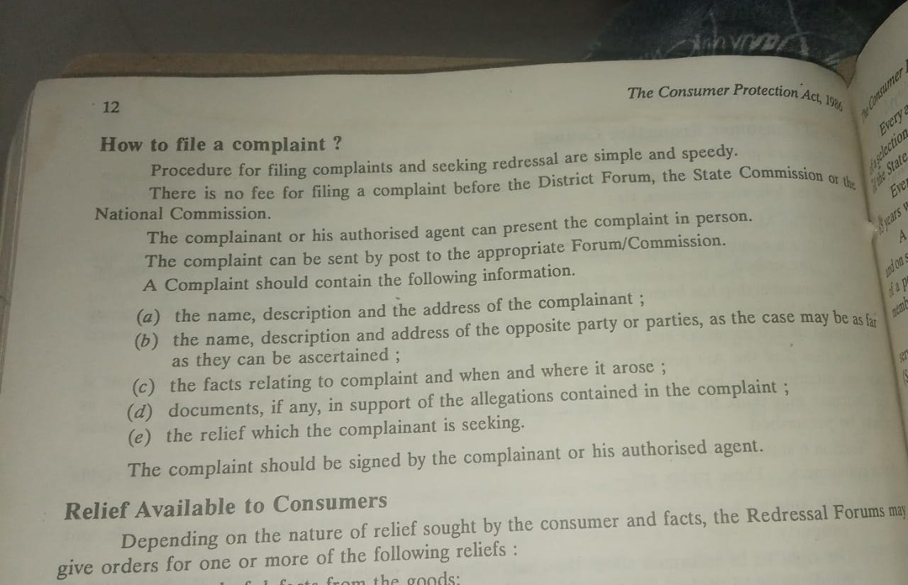

40. What are the various consumer redressal forums? Explain.

41. **Who is a Director? What are various kinds of Directors?**

The directors are the persons elected by the shareholders to direct, conduct,

manage or supervise the affairs of the company. They manage and control the

overall affairs of the company. The day to day working of the company is left

to other managerial persons appointed for the purpose.

Section 2(34) of the Companies Act, 2013 defines a ‘director’ to mean a director appointed to the Board of a company. According to section 2(10)

Board of Directors of Board in relation to a company means collectively body

of the directors of the company.

## Type of Directors Based on Functions Performed

Types of directors are of two types – executive directors and non-executive directors.

### **2.1 Executive Directors**

 Executive directors are present internally and are involved in day-to-day functions of the company – s.149(12). They are of two types – Managing Directors and Whole-Time Directors

Managing Director – A director who is the CEO and entrusted with substantial powers of management under s. 2(54) . Whole-Time Director – A director employed on a whole-time basis, not the CEO of the company and is under a special contract, appointed under s.2(94)

### 2.2  Non-Executive Directors

Non-executive directors are external professionals and uninvolved in the everyday activities of the company – s.149(12). They are of two types – independent directors and nominee directors .

**Independent Directors –** They are appointed to ensure transparency and provide expertise. Must have the following qualifications

* Industrial expertise and knowledge
* Must not have any stock options or stake in the company
* Can only be appointed for a maximum of 5 years and for 2 terms, with a minimum cooldown of 3 years between the terms.

**Nominee Directors** – Representative of the stakeholders appointed to the board of directors. Must have the following requirements – s.149(7) and s.161(3)

* Must be appointed if provided in the Articles of Association (AoA)
* Tata v. Cyrus – Must have unfettered discretion to protect the interests of both the company and the shareholders

## Types of Directors Based on Appointment

The Companies Act, 2013 allows for 3 types of directors based on appointment to deal with contingencies – Additional Director, Alternate Director and Casual Vacancy Director

### **3.1 Additional Director**

A company may appoint an additional director under s.161(1) to deal with unexpected or additional work. It must fulfil the following requirements

* Must be provided for in the AoA
* Cannot serve beyond the next Annual General Meeting
* Paul v. City Hospital – Additional Directors cannot be appointed in special circumstances to strengthen majority. You can make the [**Directors in company law**](https://vakilsearch.com/appointment-of-director) by consulting experts in your field.

### 3.2  Alternate Director

* Can be appointed under s.161(2) in the absence of the director for more than 3 months to act on his behalf if provided under AoA
* Can only serve till the managing director returns, cannot serve beyond that poin
* Must be a like for like replacement – only an independent alternate director may fill in for an alternate director

### 3.3  Casual Vacancy Director

* Can be appointed under s.161(4) on the death, resignation, disqualification or incapacity of a director
* Need not be provided for under AoA
* Can only serve till the term of the director who has vacated.
* Only applies to public companies

## Miscellaneous Types of Directors

This section deals with [**classification of directors**](https://vakilsearch.com/blog/appointment-and-qualification-of-a-director/) based on categories which may overlap with earlier categories. This section covers residential directors, women directors and small shareholders directors.

### **4.1 Residential Directors**

* Provided for in s.149(3) that [**every company**](https://vakilsearch.com/online-company-registration/company-registration-in-pune) must have at least one director who resides in India for at least 182 days in a year
* For newly incorporated companies, the requirement shall apply proportionally (50%) to the end of the FY

### 4.2  Women Directors

* Provided for in s.149(1), requires 3 types of companies to have a minimum of one women director
* Every listed company
* Every public company without a paid up share capital of 100 cr or a turnover of 300 cr.
* Companies registered prior to Companies Act, 2013: **https://www.mca.gov.in/Ministry/pdf/CompaniesAct2013.pdf** shall appoint women directors within an year of this act coming to force, while new companies post-2013 act shall appoint women directors within 6 months of registering.

### 4.3  Small Shareholders Director

* There is no mandate to appoint a small shareholders director under s.151, left up to the company’s discretion
* Companies must fulfil two criteria to be eligible to appoint a small shareholders director
* Must be a public company
* Must have at least 1000 or more small shareholders[.](https://en.wikipedia.org/wiki/Companies_Act_2013)